Batch: Roll No.:

Experiment / assignment / tutorial No._______

Grade: AA / AB / BB / BC / CC / CD /DD

Signature of the Staff In-charge with date

TITLE: Study of PCI and SCSI.

AIM: To Study and learn PCI and SCSI
______________________________________________________________________
Expected OUTCOME of Experiment:

CO 1- Describe and define the structure of a computer with buses structure.
_____________________________________________________________________
Books/ Journals/ Websites referred:

- https://www.techopedia.com/definition/8815/peripheral-component-interconnect-bus-pci-bus
- https://www.techopedia.com/definition/331/small-computer-system-interface-scsi
- http://www.csun.edu/~edaasic/roosta/BUS_Structures.pdf
- W.Stallings William “Computer Organization and Architecture: Designing for Performance”, Pearson Prentice Hall Publication, 7thEdition. C.
Pre Lab/ Prior Concepts:
Microcomputer buses which communicate with a peripheral devices or a memory location through communication lines called buses.
The major parts of microcomputers are central processing unit (CPU), memory, and input and output unit. To connect these parts together through three sets of parallel lines, called buses. These three buses are Address bus, data bus, and Control bus.

Address Bus:
The address bus consists of 16, 20, 24, or more parallel signal lines, through which the CPU sends out the address of the memory location. This memory location is used for to written to or read from. The number of memory location is depends on 2 to the power N address lines. Example, a CPU with 16 address lines can address 216 or 65,536 memory locations. When the CPU reads data from or writes data to a port. The port address is also sent out on the address bus. This is unidirectional. This means that the CPU can send data to a memory location or I/O ports.
Data Bus:
The data bus consists of 8, 16, 32 or more parallel signal lines. The data bus lines are bidirectional. This means that the CPU can read data from memory or from a I/O port as well as send data to a memory location or to a I/O port. In a system, many output devices are connected to the data bus, but only one device at a time will be enabled to the output.
Control Bus:
The control bus consists of 4-10 parallel signal lines. The CPU sends out signals on the control bus to enable the outputs of addressed memory devices or port devices. Typically control bus signals are memory read, memory write, I/O read and I/O write. To read a data from a memory location, the CPU sends out the address of the desired data on the address bus and then sends out a memory read signal on the control bus. The memory read signal enables the addressed memory device to output the data onto the data bus where it is read by the CPU.
PCI Bus

SCSI bus:

Conclusion:

Post Lab Descriptive Questions (Add questions from examination point view)
Q1 . Differentiate between PCI and SCSI Bus

Q2. List the application of PCI and SCSI Bus

Date: _____________ Signature of faculty in-charge

Batch: Roll No.:

Experiment / assignment / tutorial No._______

Grade: AA / AB / BB / BC / CC / CD /DD

Signature of the Staff In-charge with date

TITLE: To study and implement Booth’s Multiplication Algorithm.

AIM: Booth’s Algorithm for Multiplication
______________________________________________________________________
Expected OUTCOME of Experiment:

CO 2-Detail working of the arithmetic logic unit and its sub modules
_____________________________________________________________________
Books/ Journals/ Websites referred:

- Carl Hamacher, Zvonko Vranesic and Safwat Zaky, “Computer Organization”, Fifth Edition, TataMcGraw-Hill.
- William Stallings, “Computer Organization and Architecture: Designing for Performance”, Eighth Edition, Pearson.
3. Dr. M. Usha, T. S. Srikanth, “Computer System Architecture and Organization”, First Edition, Wiley-India.
_____________________________________________________________________
Pre Lab/ Prior Concepts:

It is a powerful algorithm for signed number multiplication which generates a 2n bit product and treats both positive and negative numbers uniformly. Also the efficiency of the algorithm is good due to the fact that, block of 1’s and 0’s are skipped over and subtraction/addition is only done if pair contains 10 or 01

Flowchart:

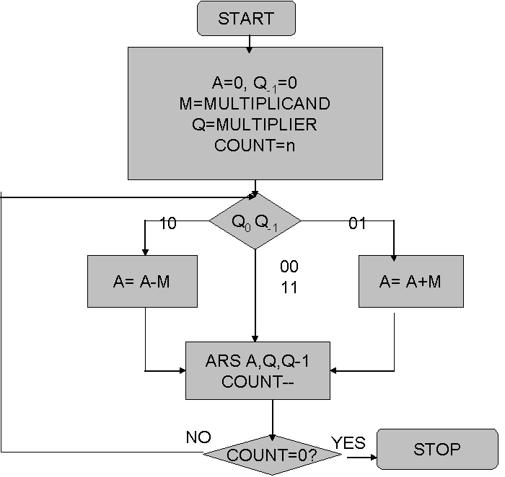

Design Steps:
- Start
- Get the multiplicand (M) and Multiplier (Q) from the user
- Initialize A= Q₋₁ =0
- Convert M and Q into binary
- Compare Q₀ and Q₋₁ and perform the respective operation.
Q₀ Q₋₁ | Operation
00/11 | Arithmetic right shift
01 | A+M and Arithmetic right shift
10 | A-M and Arithmetic right shift

6. Repeat steps 5 till all bits are compared
7. Convert the result to decimal form and display
8. End

Example:

Conclusion:
Date: _____________ Signature of faculty in-charge

Post Lab Descriptive Questions (Add questions from examination point view)

1. Draw the Circuit diagram for booths algorithm.
2. Explain advantages and disadvantages of booth algorithm

Batch: Roll No.:

Experiment / assignment / tutorial No._______

Grade: AA / AB / BB / BC / CC / CD /DD

Signature of the Staff In-charge with date

TITLE : To study and implement Restoring method of division

AIM : The basis of algorithm is based on paper and pencil approach and the operation involve repetitive shifting with addition and subtraction. So the main aim is to depict the usual process in the form of an algorithm.
______________________________________________________________________
Expected OUTCOME of Experiment:

CO 2-Detail working of the arithmetic logic unit and its sub modules
CO 3-Understand the Central processing unit with addressing modes and working of control unit
_____________________________________________________________________
Books/ Journals/ Websites referred:

- Carl Hamacher, Zvonko Vranesic and Safwat Zaky, “Computer Organization”, Fifth Edition, TataMcGraw-Hill.
- William Stallings, “Computer Organization and Architecture: Designing for Performance”, Eighth Edition, Pearson.
3. Dr. M. Usha, T. S. Srikanth, “Computer System Architecture and Organization”, First Edition, Wiley-India.
_____________________________________________________________________
Pre Lab/ Prior Concepts:
The Restoring algorithm works with any combination of positive and negative numbers.

Flowchart for Restoring of Division:
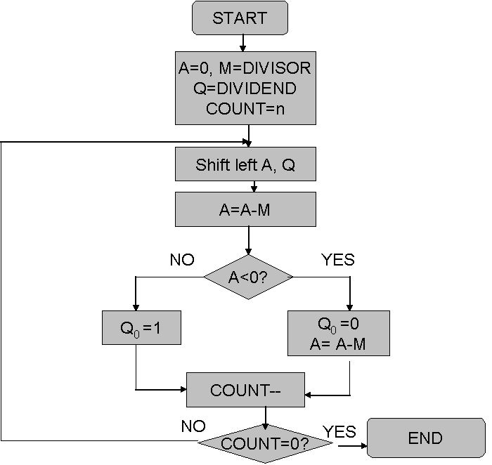

Design Steps:
- 1Start
- 2Initialize A=0, M=Divisor, Q=Dividend and count=n (no of bits)
- Left shift A, Q
- If MSB of A and M are same
- Then A=A-M
- Else A=A+M
- If MSB of previous A and present A are same
- Q₀=0 & store present A
- Else Q₀=0 & restore previous A
- Decrement count.
- If count=0 go to 11
- Else go to 3
- STOP

Example:

Conclusion

Post Lab Descriptive Questions (Add questions from examination point view)

- What are the advantages of non restoring division over restoring division?

2. Simulate non restoring division algorithm for unsigned numbers A=1101 and B=0101

Date: _____________ Signature of faculty in-charge

Batch: B2 Roll No.: 1611103

Experiment / assignment / tutorial No: 4

Grade: AA / AB / BB / BC / CC / CD /DD

Signature of the Staff In-charge with date

TITLE : To study and implement Non Restoring method of division

AIM : The basis of algorithm is based on paper and pencil approach and the operation involve repetitive shifting with addition and subtraction. So the main aim is to depict the usual process in the form of an algorithm.
______________________________________________________________________
Expected OUTCOME of Experiment:

CO 2-Detail working of the arithmetic logic unit and its sub modules
CO 3-Understand the Central processing unit with addressing modes and working of control unit
_____________________________________________________________________
Books/ Journals/ Websites referred:

- Carl Hamacher, Zvonko Vranesic and Safwat Zaky, “Computer Organization”, Fifth Edition, TataMcGraw-Hill.
- William Stallings, “Computer Organization and Architecture: Designing for Performance”, Eighth Edition, Pearson.
3. Dr. M. Usha, T. S. Srikanth, “Computer System Architecture and Organization”, First Edition, Wiley-India.
_____________________________________________________________________
Pre Lab/ Prior Concepts:
The Non Restoring algorithm works with any combination of positive and negative numbers.

Flowchart for Non-Restoring of Division:
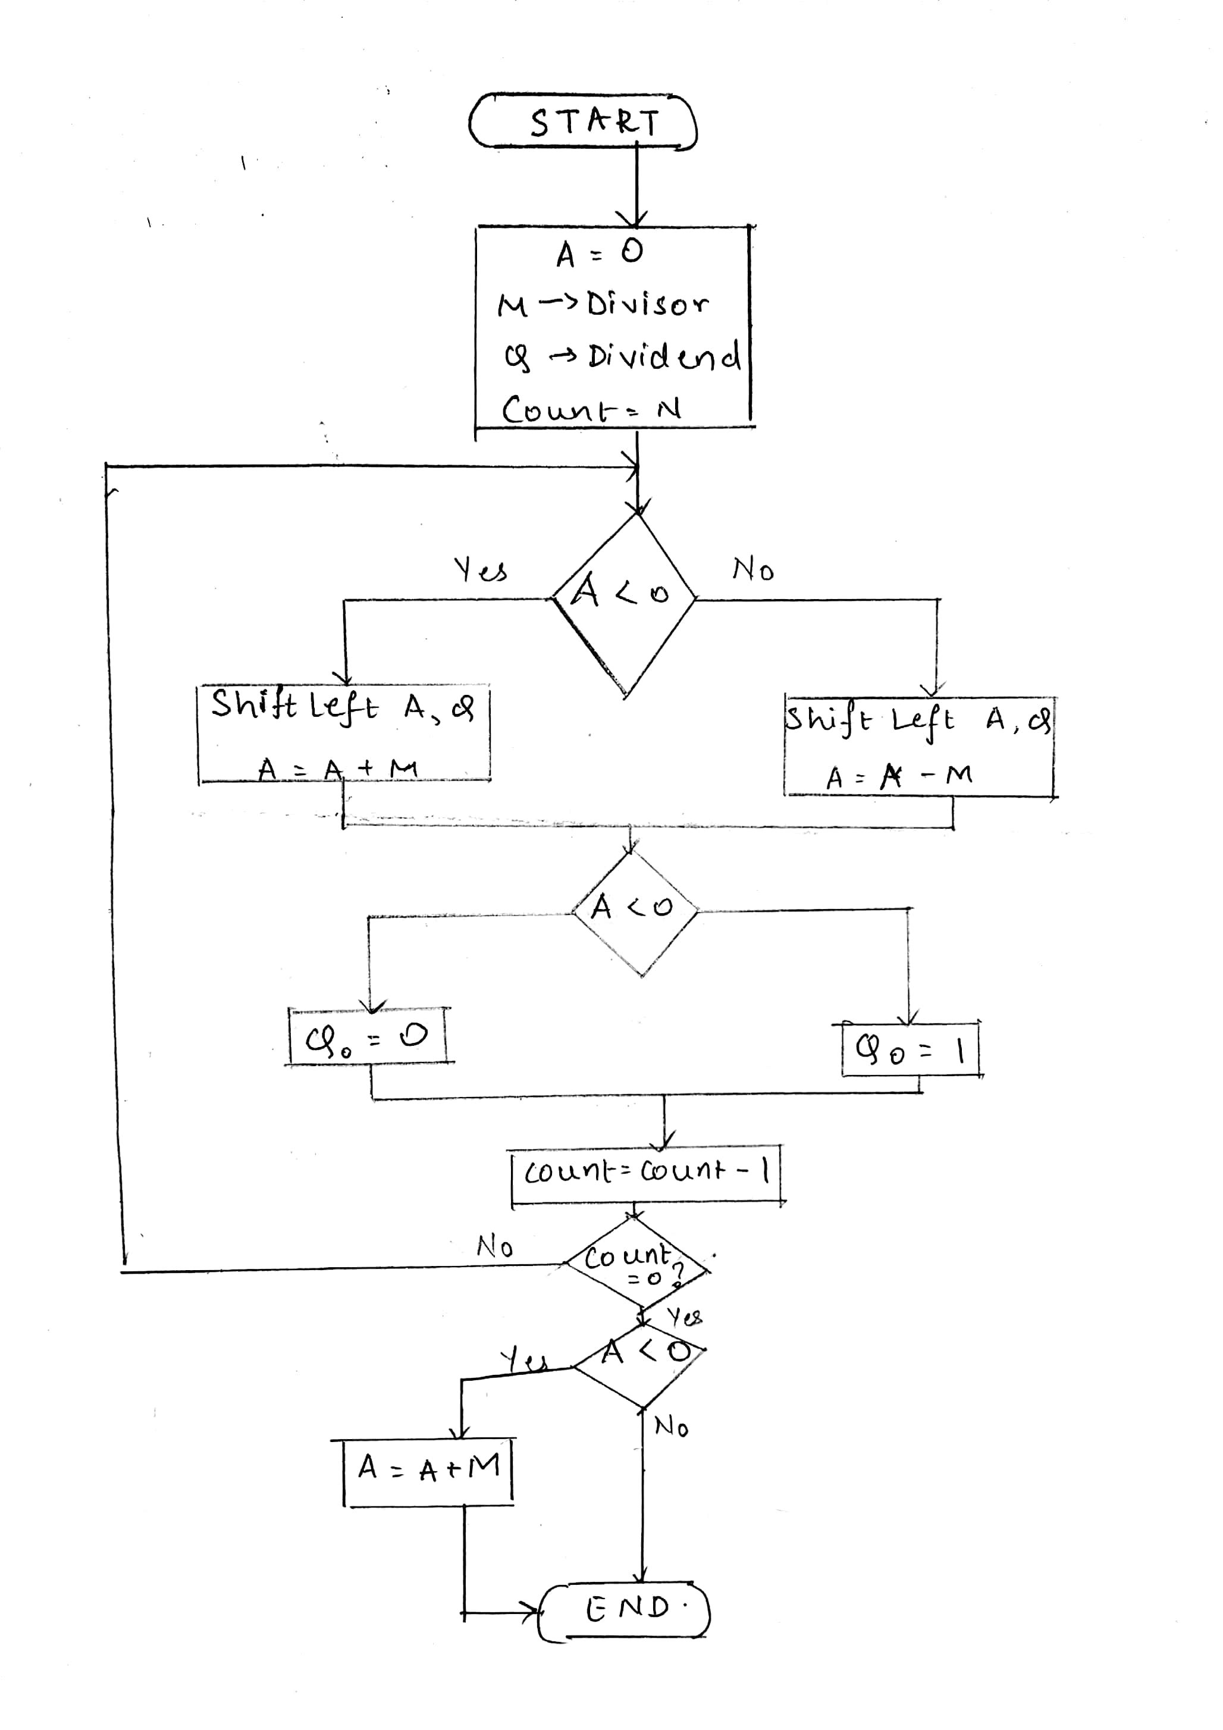
Example

#include<stdio.h>
#include<conio.h>
#define MAXB 15
#define MAX 16
//using namespace std;
void bic(int l,int p[])
{
int i = 0;
while(l != 0)
{
p[i] = l%2;
i++;
if(i >= MAX)
l = 0;
else
l = l/2;
}
for(;i<MAX;i++)
{
p[i] = 0;
}
}
void printb(int n[])
{
for(int i = MAXB;i>=0;i--)
{
printf("%d",n[i]);
}
printf("\t");
}
int check(int a[])
{
if(a[MAXB] == 1)
return 1;
else if(a[MAXB] == 0)
return 2;
else
return 3;
}
void add(int A[],int m[])
{
int carry = 0;
for(int i =0;i<MAX;i++)
{
A[i] = A[i] + m[i] + carry ;
carry = 0;
if(A[i] == 2)
{
A[i] = 0;
carry = 1;
}
else if(A[i] == 3)
{
A[i] = 1;
carry = 1;
}
else
continue;
}
}
void sub(int a[],int m[])
{
int n[MAX];
for(int j = 0;j<MAX;j++)
{
n[j] = m[j];
}
for(int i = MAXB;i>=0;i--)
{
if(n[i] == 0)
{
n[i] = 1;
continue;
}
else if(n[i] == 1)
{
n[i] = 0;
continue;
}
}
int m1[] = {1,0,0,0,0,0,0,0,0,0,0,0,0,0,0,0};
add(n,m1);
add(a,n);
}
void shift(int a[],int q[])
{
int temp = q[MAXB];
for(int i = MAXB;i>0;i--)
{
a[i] = a[i-1];
q[i] = q[i-1];
}
a[0] = temp;
}
void main()
{
clrscr();
int M,Q,count = MAX;
printf("Enter the numerator : ");
scanf("%d",&Q);
printf("Enter the denominator : ");
scanf("%d",&M);
int m[MAX],q[MAX];
bic(M,m);
bic(Q,q);
//printb(m);
//printb(q);
int A[16];
for(int i = 0;i<MAX;i++)
{
A[i] = 0;
}
label:
switch(check(A))
{
case 2 :shift(A,q);
sub(A,m);
break;
case 1 :shift(A,q);
add(A,m);
break;
case 3 :printf("error!:-(");
count = 0;
break;
default :break;
}
switch(check(A))
{
case 1:
q[0] = 0;
break;
case 2:
q[0] = 1;
break;
case 3:printf("Error");
count = 0;
break;
}
count--;
if(count>0)
goto label;
else
{
if(check(A) == 1)
add(A,m);
printf("The division of the given nos: \nRemainder: ");
printb(A);
printf("\nQuotient : ");
printb(q);
}
//return 0;
getch();
}

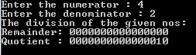

Conclusion
Therefore we have successfully implemented non-restoring division algorithm in C Programming Language.
Post Lab Descriptive Questions (Add questions from examination point view)

- What are the advantages of non-restoring division over restoring division?

2. Simulate non restoring division algorithm for unsigned numbers A=1101 and B=0101

Ans 1)
Non restoring dividion prevents the need for an extra restoring operation in the restoring step and thus reduces the step computation.

Ans 2)

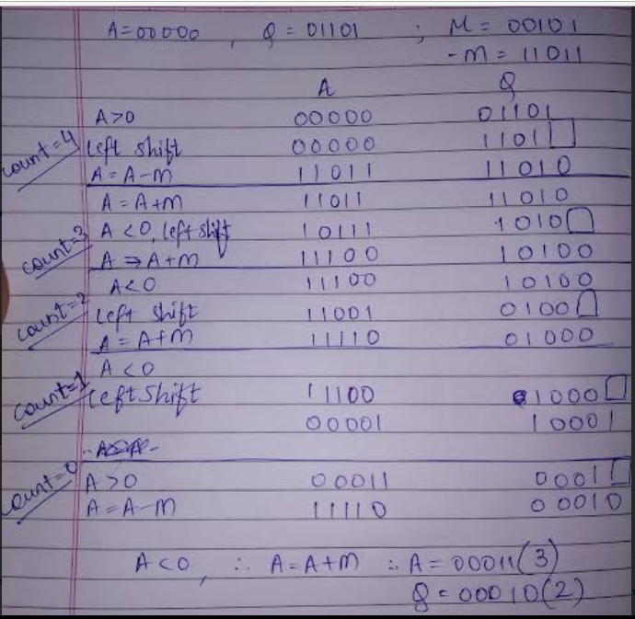

Batch: B2 Roll No.: 1611103

Experiment / assignment / tutorial No. 5

Grade: AA / AB / BB / BC / CC / CD /DD

Signature of the Staff In-charge with date

TITLE: Implementation of IEEE-754 floating point representation

AIM: To demonstrate the single and double precision formats to represent floating point numbers.
______________________________________________________________________
Expected OUTCOME of Experiment:

CO 2-Detail working of the arithmetic logic unit and its sub modules
___________________________________________________________________
Books/ Journals/ Websites referred:
- Carl Hamacher, Zvonko Vranesic and Safwat Zaky, “Computer Organization”, Fifth Edition, TataMcGraw-Hill.
- William Stallings, “Computer Organization and Architecture: Designing for Performance”, Eighth Edition, Pearson.
_____________________________________________________________________
Pre Lab/ Prior Concepts:
The IEEE Standard for Floating-Point Arithmetic (IEEE 754) is a technical standard for floating-point computation established in 1985 by the Institute of Electrical and Electronics Engineers (IEEE). The standard addressed many problems found in the diverse floating point implementations that made them difficult to use reliably and portably. Many hardware floating point units now use the IEEE 754 standard.
The standard defines:
- arithmetic formats: sets of binary and decimal floating-point data, which consist of finite numbers (including signed zeros and subnormal numbers), infinities, and special "not a number" values (NaNs)
- interchange formats: encodings (bit strings) that may be used to exchange floating-point data in an efficient and compact form
- rounding rules: properties to be satisfied when rounding numbers during arithmetic and conversions
- operations: arithmetic and other operations (such as trigonometric functions) on arithmetic formats
- exception handling: indications of exceptional conditions (such as division by zero, overflow, etc

Example (Single Precision- 32 bit representation)

#include <iostream>
#include<stdlib.h>
//#include<conio.h>
#define MAX 32
#define MAX64 64
using namespace std;

int bic(int a[],int x)
{
int i = 0;
while(x && i<MAX)
{
a[i++] = x%2;
x = x/2;
}
return i;
}

int floatB(int b[],float y)
{
int i = 0;
while(y!=0.000000 && i<MAX)
{
b[i++] = (int)(y*2);
y = (y*2) - (int)(y*2);
}
for(int j = 0;j<i/2;j++)
{
int temp = b[i-j-1];
b[i-j-1] = b[j];
b[j] = temp;
}
return i;
}

int main()
{
//clrscr();
float x = 0;
cout<<"WELCOME TO IEEE CONVERTER:-)\nEnter your number : ";
cin>>x;
int num[MAX];
if(x >=0)
{
num[0] = 0;
}
else
{
num[0] = 1;
x = -x;
}
int exp = (int)x;
x = x -(int)x;
int EXP[MAX],MANT[MAX];
int pow = bic(EXP,exp) - 1;
int len = floatB(MANT,x) - 1;
/*pow +=127;*/int temp = 128; //use pow+=1023 and temp to 1024 for 64 bit
if(pow >0 || (pow ==0 && EXP[pow] ==1)) //to insert binary equivalent of exponent in array
{
pow += 127;
for(int i = 1;i<9;i++ ) //i<11 for 64 bit
{
num[i] = (pow&temp)?1:0;
temp/=2;
}
}
else
{
temp = len;
while(temp>=0)
{
if(MANT[temp--] == 1)
{pow = temp - len ;break;}
}
len += pow;
pow+=127;temp = 128;
for(int i = 1;i<9;i++ ) //i<11 for 64 bit
{
num[i] = (pow&temp)?1:0;
temp = temp>>1;
}
}
pow -=127;
//temp = pow - 1; //setting pointer to get mantissa
for(int i = 0;i<pow;i++)
{
MANT[++len] = EXP[i]; //copy mantissa part
}
for(int i = 9;i<MAX && len>=0;i++)
{
num[i] = MANT[len--];
temp = i;
}
cout<<"GIVEN NO. IN IEEE FORMAT IS : \n";
cout<<num[0]<<" ||| ";
for(int i = 1;i<9 ;i++)
{
cout<<num[i]<<" ";
}
cout<<" ||| ";
for(int i = 9;i<=temp;i++)
{
cout<<num[i]<<" ";
}
cout<<"0\n";
//getch();
return 0;
}

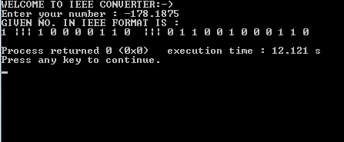

Example (Double Precision- 64 bit representation)

#include <iostream>
#include<stdlib.h>
//#include<conio.h>
#define MAX 64
using namespace std;

int bic(int a[],int x)
{
int i = 0;
while(x && i<MAX)
{
a[i++] = x%2;
x = x/2;
}
return i;
}

int floatB(int b[],float y)
{
int i = 0;
while(y!=0.000000 && i<MAX)
{
b[i++] = (int)(y*2);
y = (y*2) - (int)(y*2);
}
for(int j = 0;j<i/2;j++)
{
int temp = b[i-j-1];
b[i-j-1] = b[j];
b[j] = temp;
}
return i;
}

int main()
{
//clrscr();
float x = 0;
cout<<"WELCOME TO IEEE CONVERTER:-)\nEnter your number : ";
cin>>x;
int num[MAX];
if(x >=0)
{
num[0] = 0;
}
else
{
num[0] = 1;
x = -x;
}
int exp = (int)x;
x = x -(int)x;
int EXP[MAX],MANT[MAX];
int pow = bic(EXP,exp) - 1;
int len = floatB(MANT,x) - 1;
/*pow +=127;*/int temp = 1024; //use pow+=1023 and temp to 1024 for 64 bit
if(pow >0 || (pow ==0 && EXP[pow] ==1)) //to insert binary equivalent of exponent in array
{
pow += 1023;
for(int i = 1;i<12;i++ ) //i<11 for 64 bit
{
num[i] = (pow&temp)?1:0;
temp/=2;
}
}
else
{
temp = len;
while(temp>=0)
{
if(MANT[temp--] == 1)
{pow = temp - len ;break;}
}
len += pow;
pow+=1023;temp = 1024;
for(int i = 1;i<12;i++ ) //i<11 for 64 bit
{
num[i] = (pow&temp)?1:0;
temp = temp>>1;
}
}
pow -=1023;
//temp = pow - 1; //setting pointer to get mantissa
for(int i = 0;i<pow;i++)
{
MANT[++len] = EXP[i]; //copy mantissa part
}
for(int i = 12;i<MAX && len>=0;i++)
{
num[i] = MANT[len--];
temp = i;
}
cout<<"GIVEN NO. IN IEEE FORMAT IS : \n";
cout<<num[0]<<" ||| ";
for(int i = 1;i<12 ;i++)
{
cout<<num[i]<<" ";
}
cout<<" ||| ";
for(int i = 12;i<=temp;i++)
{
cout<<num[i]<<" ";
}
cout<<"0\n";
//getch();
return 0;
}

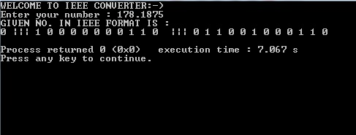

Post Lab Descriptive Questions (Add questions from examination point view)
- Give the importance of IEEE-754 representation for floating point numbers?

Ans. IEEE-754 provides a proper algorithm for arithmetic operations on floating point values. Its standards are as follows:-
- arithmetic formats: sets of binary and decimal floating-point data, which consist of finite numbers (including signed zeros and subnormal numbers), infinities, and special "not a number" values (NaNs)
- interchange formats: encodings (bit strings) that may be used to exchange floating-point data in an efficient and compact form
- rounding rules: properties to be satisfied when rounding numbers during arithmetic and conversions
- operations: arithmetic and other operations (such as trigonometric functions) on arithmetic formats
- exception handling: indications of exceptional conditions (such as division by zero, overflow, etc.)

Conclusion
Hence we have successfully demonstrated the single and double precision formats to represent floating point numbers in C programming language.
Date: _____________ Signature of faculty in-charge

Batch: B2 Roll No.: 1611103

Experiment / assignment / tutorial No._______

Grade: AA / AB / BB / BC / CC / CD /DD

Signature of the Staff In-charge with date

TITLE: Implementation of LRU Page Replacement Algorithm.

AIM: The LRU algorithm replaces the least recently used that is the last accessed memory block from user.
______________________________________________________________________
Expected OUTCOME of Experiment:

CO 4-Learn and evaluate memory organization and cache structure
___________________________________________________________________
Books/ Journals/ Websites referred:
- Carl Hamacher, Zvonko Vranesic and Safwat Zaky, “Computer Organization”, Fifth Edition, TataMcGraw-Hill.
- William Stallings, “Computer Organization and Architecture: Designing for Performance”, Eighth Edition, Pearson.
_____________________________________________________________________
Pre Lab/ Prior Concepts:

It follows a simple logic, while replacing it will replace that page which has least recently used out of all.
a) A hit is said to be occurred when a memory location requested is already in the cache.
b) When cache is not full, the number of blocks is added.
c) When cache is full, the block is replaced which is recently used
Algorithm:

- Start
- Get input as memory block to be added to cache
- Consider an element of the array
- If cache is not full, add element to the cache array
- If cache is full, check if element is already present
- If it is hit is incremented
- If not, element is added to cache removing least recently used element
- Repeat step 3 to 7 for remaining elements
- Display the cache at very instance of step 8
- Print hit ratio
- End

Example:

#include<iostream>
#define WINDOW 2
using namespace std;
int check(int a[],int r,int ele)
{
for(int i = 0;i<=r;i++)
{
if(a[i] == ele)
return i; //to Hid
}
if(r == WINDOW)
return 4; //delete last used element
else if(r<WINDOW)
return 5; //to just insert
}
void hid(int a[],int pos,int rp,int ele)
{
int temp = a[pos];
for(int i = pos;i<rp;i++)
a[i] = a[i+1];
a[rp] = temp;
}
int main()
{
int page[WINDOW+1],rp,LRU;
rp = -1;
int x = 0;
do
{
cout<<endl;
cout<<"Enter the number(-1 to quit) : ";
cin>>x;
cout<<endl;
if(x == -1)
break;
switch(check(page,rp,x))
{
case 5 : page[++rp] = x; //inserting
break;
case 4 : //del LRU n inserting
cout<<page[0]<<" is the least recently used.\nDeleting and inserting new page......\n";
for(int i =0;i<WINDOW;i++)
{
page[i] = page[i+1];
}
page[rp] = x;
break;
default : hid(page,check(page,rp,x),rp,x);
cout<<"Hit!!\n";
break;
}
LRU = page[0];
cout<<"The cache is : \n";
for(int j =0;j<=rp;j++)
cout<<page[j]<<"\t";
cout<<"\nLeast Recently Used Page : "<<LRU<<endl;
}while(x!=-1);
}

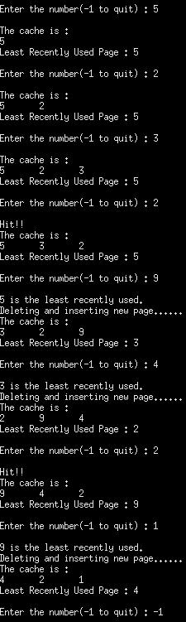

Post Lab Descriptive Questions (Add questions from examination point view)

1. Define hit rate and miss ratio?

Ans. Occurrence of Hit ─ in a level when the address
that an operation references is found in that
level of the memory hierarchy otherwise, a Miss
It is also defined as The chief measurement of a cache, which is the percentage of all accesses that are satisfied by the data in the cache.
The miss ratio is the fraction of accesses which are a miss. It holds that miss rate=1−hit rate. The (hit/miss) latency (AKA access time) is the time it takes to fetch the data in case of a hit/miss. If the access was a hit - this time is rather short because the data is already in the cache.

2. What is the need for virtual memory?

In computing, virtual memory is a memory management technique that is implemented using both hardware and software. It maps memory addresses used by a program, called virtual addresses, into physical addresses in computer memory. Main storage, as seen by a process or task, appears as a contiguous address space or collection of contiguous segments. The operating system manages virtual address spaces and the assignment of real memory to virtual memory. Address translation hardware in the CPU, often referred to as a memory management unit or MMU, automatically translates virtual addresses to physical addresses. Software within the operating system may extend these capabilities to provide a virtual address space that can exceed the capacity of real memory and thus reference more memory than is physically present in the computer.
The primary benefits of virtual memory include freeing applications from having to manage a shared memory space, increased security due to memory isolation, and being able to conceptually use more memory than might be physically available, using the technique of paging.

Conclusion
Hence the LRU algorithm is studied and implemented in C++.

Date: _____________ Signature of faculty in-charge

Batch: B2 Roll No.: 1611103

Experiment / assignment / tutorial No._______

Grade: AA / AB / BB / BC / CC / CD /DD

Signature of the Staff In-charge with date

TITLE :Implementation of FIFO Page Replacement Algorithm

AIM: The FIFO algorithm uses the principle that the block in the set which has been in for the longest time will be replaced
______________________________________________________________________
Expected OUTCOME of Experiment:
CO 4-Learn and evaluate memory organization and cache structure
_____________________________________________________________________
Books/ Journals/ Websites referred:
- Carl Hamacher, Zvonko Vranesic and Safwat Zaky, “Computer Organization”, Fifth Edition, TataMcGraw-Hill.
- William Stallings, “Computer Organization and Architecture: Designing for Performance”, Eighth Edition, Pearson.
3. Dr. M. Usha, T. S. Srikanth, “Computer System Architecture and Organization”, First Edition, Wiley-India.
---------------------------------------------------------------------------------------------------------
Pre Lab/ Prior Concepts:

T he FIFO algorithm uses the principle that the block in the set which has been in the block for the longest time is replaced. FIFO is easily implemented as a round robin or criteria buffer technique. The data structure used for implementation is a queue. Assume that the number of cache pages is three. Let the request to this cache is shown alongside.

Algorithm:

1. A hit is said to be occurred when a memory location requested is already in the cache.
2. When cache is not full, the number of blocks is added.
3. When cache is full, the block is replaced which was added first

Design Steps:

- Start
- Get input as memory block to be added to cache
- Consider an element of the array
- If cache is not full, add element to the cache array
- If cache is full, check if element is already present
- If it is hit is incremented
- If not, element is added to cache removing first element (which is in first).
- Repeat step 3 to 7 for remaining elements
- Display the cache at very instance of step 8
- Print hit ratio
- End.

Example:

#include<stdio.h>
//#include<conio.h>
#define WINDOW 2

int check(int a[],int r,int ele)
{
for(int i = 0;i<=r;i++)
{
if(a[i] == ele)
return i; //to HIT
}
if(r == WINDOW)
return 4; //delete last used element and insert new.
else if(r<WINDOW)
return 5; //to just insert
}

int main()
{
int in,page[WINDOW+1],rp = -1,FI;
label:
printf("Enter element to insert (-1 to Quit) : \n");
scanf("%d",&in);
if(in != -1){
switch( check(page,rp,in) )
{
case 5: page[++rp] = in;
break;
case 4: printf("%d is the first element to enter.Deleting and inserting new : \n",FI);
for(int i =0;i<WINDOW;i++)
{
page[i] = page[i+1];
}
page[rp] = in ;
break;
default: printf(“Hit!!!\n”);
break;
}
FI = page[0];
printf("The cache is : \n");
for(int i = 0;i<=rp;i++)
{
printf("%d ",page[i]);
}
printf("\nFirst Entered Element : %d\n",FI);
goto label;
}
return 0;
}

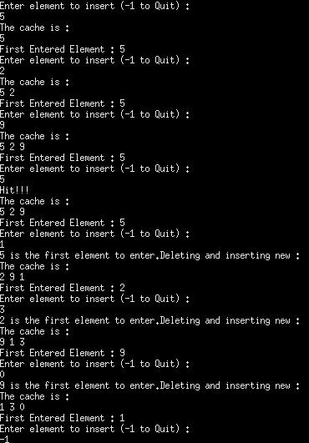

Post Lab Descriptive Questions (Add questions from examination point view)

1. What is meant by memory interleaving?
Ans. In computing, interleaved memory is a design made to compensate for the relatively slow speed of dynamic random-access memory (DRAM) or core memory, by spreading memory addresses evenly across memory banks. That way, contiguous memory reads and writes are using each memory bank in turn, resulting in higher memory throughputs due to reduced waiting for memory banks to become ready for desired operations.
With interleaved memory, memory addresses are allocated to each memory bank in turn. For example, in an interleaved system with two memory banks (assuming word-addressable memory), if logical address 32 belongs to bank 0, then logical address 33 would belong to bank 1, logical address 34 would belong to bank 0, and so on. An interleaved memory is said to be n-way interleaved when there are n banks and memory location i resides in bank i mod n.Interleaved memory results in contiguous reads (which are common both in multimedia and execution of programs) and contiguous writes (which are used frequently when filling storage or communication buffers) actually using each memory bank in turn, instead of using the same one repeatedly. This results in significantly higher memory throughput as each bank has a minimum waiting time between reads and writes.

2. Explain Paging Concept?
Ans. In computer operating systems, paging is a memory management scheme by which a computer stores and retrieves data from secondary storage for use in main memory. In this scheme, the operating system retrieves data from secondary storage in same-size blocks called pages. Paging is an important part of virtual memory implementations in modern operating systems, using secondary storage to let programs exceed the size of available physical memory. Here the main memory is referes to RAM and secondary storage to Hard disk.
Conclusion
Hence the FIFO page replacement policy is studied and implemented in C++.

Date: _____________ Signature of faculty in-charge

Batch: Roll No.:

Experiment / assignment / tutorial No._______

Grade: AA / AB / BB / BC / CC / CD /DD

Signature of the Staff In-charge with date

TITLE : Implementation of Cache Mapping Techniques.

AIM: To study and implement concept of various mapping techniques designed for cache memory.
______________________________________________________________________
Expected OUTCOME of Experiment:
CO 4-Learn and evaluate memory organization and cache structure
_____________________________________________________________________
Books/ Journals/ Websites referred:

- Carl Hamacher, Zvonko Vranesic and Safwat Zaky, “Computer Organization”, Fifth Edition, TataMcGraw-Hill.
- Dr. M. Usha, T. S. Srikanth, “Computer System Architecture and Organization”, First Edition, Wiley-India.
___________________________________________________________
Pre Lab/ Prior Concepts:

Cache memory: The cache is a smaller, faster memory which stores copies of the data from the most frequently used main memory locations. As long as most memory accesses are cached memory locations, the average latency of memory accesses will be closer to the cache latency than to the latency of main memory.
2. Hit Ratio: You want to increase as much as possible the likelihood of the cache containing the memory addresses that the processor wants.
Hit Ratio= No. of hits/ (No. of hits + No. of misses)
There are only fewer cache lines than the main memory blocks, an algorithm is needed for mapping main memory blocks into cache lines. Further a means is needed for determining which main memory block currently occupies in a cache line. The choice of cache function dictates how the cache is organized. Three techniques can be used.
- Direct mapping.
- Associative mapping.
- Set Associative mapping.
Direct Mapped Cache: The direct mapped cache is the simplest form of cache and the easiest to check for a hit. Since there is only one possible place that any memory location can be cached, there is nothing to search; the line either contains the memory information we are looking for, or it doesn't.
Unfortunately, the direct mapped cache also has the worst performance, because again there is only one place that any address can be stored. Let's look again at our 512 KB level 2 cache and 64 MB of system memory. As you recall this cache has 16,384 lines (assuming 32-byte cache lines) and so each one is shared by 4,096 memory addresses. In the absolute worst case, imagine that the processor needs 2 different addresses (call them X and Y) that both map to the same cache line, in alternating sequence (X, Y, X, Y). This could happen in a small loop if you were unlucky. The processor will load X from memory and store it in cache. Then it will look in the cache for Y, but Y uses the same cache line as X, so it won't be there. So Y is loaded from memory, and stored in the cache for future use. But then the processor requests X, and looks in the cache only to find Y. This conflict repeats over and over. The net result is that the hit ratio here is 0%. This is a worst case scenario, but in general the performance is worst for this type of mapping.

Fully Associative Cache: The fully associative cache has the best hit ratio because any line in the cache can hold any address that needs to be cached. This means the problem seen in the direct mapped cache disappears, because there is no dedicated single line that an address must use.However (you knew it was coming), this cache suffers from problems involving searching the cache. If a given address can be stored in any of 16,384 lines, how do you know where it is? Even with specialized hardware to do the searching, a performance penalty is incurred. And this penalty occurs for all accesses to memory, whether a cache hit occurs or not, because it is part of searching the cache to determine a hit. In addition, more logic must be added to determine which of the various lines to use when a new entry must be added (usually some form of a "least recently used" algorithm is employed to decide which cache line to use next). All this overhead adds cost, complexity and execution time.
Set Associative Cache:

Direct Mapping Implementation:
The mapping is expressed as
i=j modulo m
i=cache line number
j= main memory block number
m= number of lines in the cache
- Address length = (s+w) bits
- Number of addressable units = 2^{s+w} words or bytes
- Block size = line size = 2^{w} words or bytes
- Number of blocks in main memory = 2^{s+w} / 2^{w} = 2^{s}
- Number of lines in cache = m = 2^{r}
- Size of tag = (s-r) tags

Associative Mapping Implementation:

Set Associative Mapping Implementation:

Post Lab Descriptive Questions (Add questions from examination point view)

1. For a direct mapped cache, a main memory is viewed as consisting of 3 fields. List and define 3 fields.

2. What is the general relationship among access time, memory cost, and capacity?

Conclusion

Date: _____________ Signature of faculty in-charge

Batch: Roll No.:

Experiment / assignment / tutorial No._______

Grade: AA / AB / BB / BC / CC / CD /DD

Signature of the Staff In-charge with date

TITLE: Implementation of RAID levels

AIM: Understanding RAID levels and their importance
_______________________________________________________________
Expected OUTCOME of Experiment:
CO 4-Learn and evaluate memory organization and cache structure
CO 5- Summarize Input output techniques and multiprocessor configurations
__________________________________________________________________
Books/ Journals/ Websites referred:

- Carl Hamacher, Zvonko Vranesic and Safwat Zaky, “Computer Organization”, Fifth Edition, TataMcGraw-Hill.
- William Stallings, “Computer Organization and Architecture: Designing for Performance”, Eighth Edition, Pearson.
3. Dr. M. Usha, T. S. Srikanth, “Computer System Architecture and Organization”, First Edition, Wiley-India.
_____________________________________________________________________

Pre Lab/ Prior Concepts: RAID: Short for Redundant Array of Independent (or Inexpensive) Disks, a category of disk drives that employ two or more drives in combination for fault tolerance and performance. RAID disk drives are used frequently on servers but aren't generally necessary for personal computers. RAID allows you to store the same data redundantly (in multiple paces) in a balanced ay to improve overall performance.
Disk Drives: A machine that reads data from and writes data onto a disk. A disk drive
rotates the disk very fast and has one or more heads that read and write data
Fault Tolerance: The ability of a system to respond gracefully to an unexpected hardware or software failure. There are many levels of fault tolerance, the lowest being the ability to continue operation in the event of a power failure. Many fault-tolerant computer systems mirror all operations -- that is, every operation is performed on two or more duplicate systems, so if one fails the other can take over
Resources required: c programming.

Methodology:
RAID 0
.
A RAID 0 (also known as a stripe set or striped volume) splits data evenly across two or more disks (striped) with no parity information for redundancy. It is important to note that RAID 0 was not one of the original RAID levels and provides no data redundancy. RAID 0
is normally used to increase performance, although it can also be used as a way to create a small number of large virtual disks out of a large number of small physical ones. A RAID 0 can be created with disks of differing sizes, but the storage space added to the array by each disk is limited to the size of the smallest disk. For example, if a 120 GB disk is striped together with a 100 GB disk, the size of the array will be 200 GB.

RAID 1
A RAID 1 creates an exact copy (or mirror) of a set of data on two or more disks. This is
useful when read performance or reliability are more important than data storage
capacity such an array can only be as big as the smallest member disk. A classic RAID 1 mirrored pair contains two disks (see diagram), which increases reliability geometrically each member contains a complete copy of the data, and can be addressed independently, ordinary wear-and-tear reliability is raised by the power of the number of self-contained copies.
.
RAID 2
A RAID 2 stripes data at the bit (rather than block) level, and uses a Hamming code for
error correction. The disks are synchronized by the controller to spin in perfect tandem.
Extremely high data transfer rates are possible. This is the only original level of RAID that is not currently used.
The use of the Hamming(7,4) code (four data bits plus three parity bits) also permits using 7 disks in RAID 2, with 4 being used for data storage and 3 being used for error
correction.RAID 2 is the only standard RAID level, other than some implementations of RAID 6,which can automatically recover accurate data from single-bit corruption in data. Other RAID levels can detect single-bit corruption in data, or can sometimes reconstruct missing data, but cannot reliably resolve contradictions between parity bits and data bits without human intervention.
(Multiple-bit corruption is possible though extremely rare. RAID 2 can detect but not repair double-bit corruption.)
At the present time, there are no commercial implementations of RAID 2

Design Steps:
Raid level 0

Raid level 1

Raid level 2

Post Lab Descriptive Questions (Add questions from examination point view)

1. What are the applications of RAID levels ? Which level is the most secure?

Conclusion

Date: _____________ Signature of faculty in-charge

